ELL – Coding and Technology
Big Ideas
- Exploring and sharing multiple perspectives extends our thinking
- Language and text can be a source of creativity and joy
- Meaning can be conveyed in multiple ways through language
- Developing computational fluency comes from understanding the basics of programming

Students are expected to know the following:
- Elements of computational vocabulary (algorithm, coding,etc.)
- Be able practice coding instructions with symbols
- Design and share information in innovative ways.
Prior knowledge:
BBC Learning English
1. You and Technology : multiple choice personality quiz

http://www.bbc.co.uk/learningenglish/english/course/lower-intermediate/unit-28/session-1

2. The great digital debate: watch video and answer T/F activities b: Listen to audio and anser comprehension questions

http://www.bbc.co.uk/learningenglish/english/course/lower-intermediate/unit-17/session-1

Library lessons:
Lesson 1: Intro to technology and computational thinking
1. slide show about technology https://docs.google.com/presentation/d/1J7BEGqlLznCn9AZgmnNG-yuuJtP5360sAGG-_TPSuRY/edit?usp=sharing

2. Barack Obama video from Code.org

3. Activity : Coding : unplugged “My Robotic Friends” https://csedweek.org/files/CSEDrobotics.pdf

Lesson 2 – Coding using computers –Drawing on a canvas
- Watch video: Computational thinking https://studio.code.org/s/course3

- Generate a computer science “mind map” : What is CS and why it matters

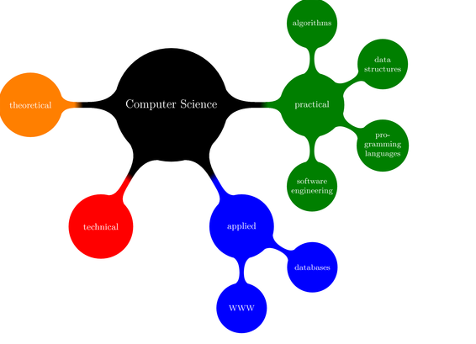
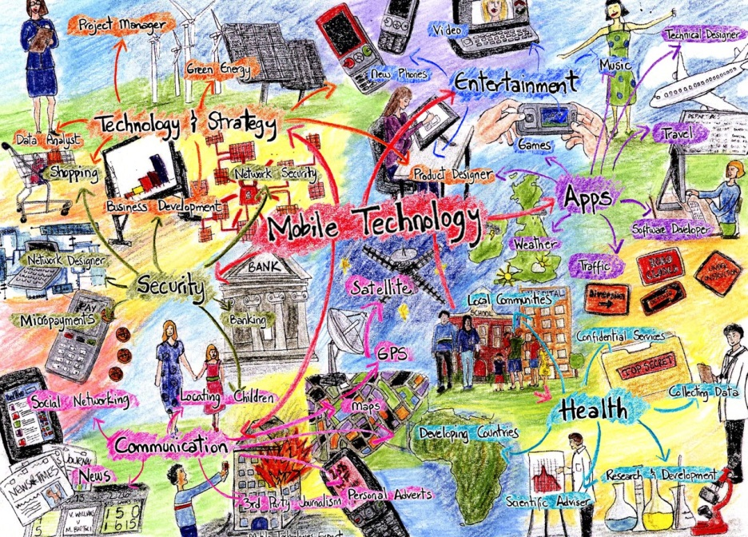

https://www.wisecampaign.org.uk/uploads/wise/files/mobiletechnologymindmap.jpg

3. Show intro video for Artist program. https://www.youtube.com/watch?v=MUavAHn-QUg

4. . Coding using Artist.

Let students know about options for continuing to code. Visit code.org/learn.
Ie: Star Wars: building a galaxy with code.

5. Assign summative task : Powerpoint presentation: The impact of technology on our lives.

SUMMATIVE EVALUATION: The impact of technology on our lives
Task: Research these 8 areas of technology and find an example of innovation in this area.
Make 6 Powerpoint / Prezi / digital slides with an image and a short explanation.
Example: Virtual Reality
Short explanation: Virtual reality is when a computer artificially creates an experience. This is an example of a flight simulator. It is used to teach pilots how to fly planes and how to handle dangerous situations in a safe environment.
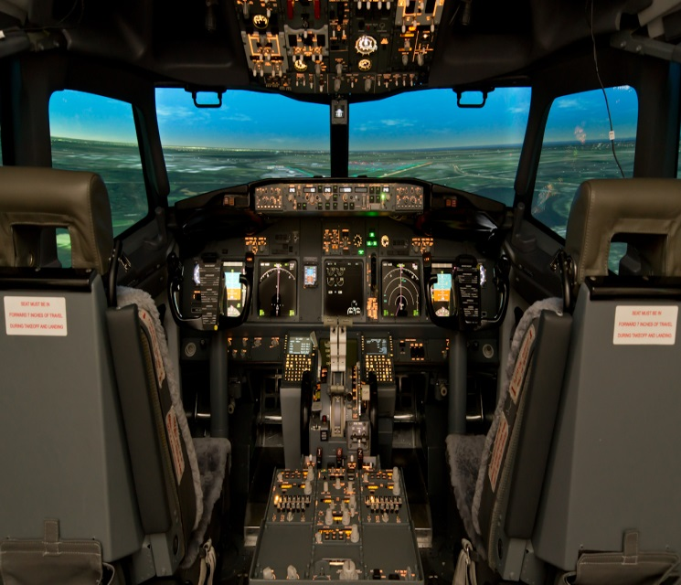
Categories: Choose 6
- Virtual Reality
- Buildings and homes (construction, design, appliances)
- Medicine
- Transportation (land, air, space)
- Communication
- Assistive technology (for people with physical disabilities)
- Machines and robots
- Military

Evaluation Criteria

Superior (4)

Clearly meets all criteria set in instructions
Interesting and also entertaining
Very clearly presents a message
Shows careful planning and organization of material
Interesting and relevant details
No,or minimal, errors in grammar, spelling, structure (written and oral)
Easily understood
Has examples, well presented with colourful visuals

Good (3)
Meets the criteria set out in the instructions
Holds audience or reader interest
Shows evidence of planning and organization
Clearly presented ideas
Includes relevant detail
A few errors
Neatly completed
Visuals and valid examples

SATISFACTORY (2)
Meets most of the criteria set out in the instructions
Can be understood and followed
Evidence of some planning
Occasionally difficult to follow
Quite a few errors
Neatness needs attention
Lack of visuals or examples

INCOMPLETE (1)
Has met few criteria set out in instructions
Many errors
Messy and lacks organization
Little or no specified content
No attempt to create interest

